**Presentation Notes:**

1. What are the four functions of a computer program listed on the lesson slide?
   1. A Computer Program controls the hardware of a computer system.
   2. It makes decisions about how Input Devices affect Output Devices
   3. Changing the program changes the function of the computer hardware
   4. Computer Programs control more than just traditional computer systems.
2. Provide an example of a computer input that is not listed on the lesson slide.

An example of an input device is a microphone.

1. Provide an example of a computer output that is not listed on the lesson slide.

An example of an output device are speakers.

1. Provide another example of how a computer input affects a computer output that is not listed on the lesson slide.

If you use a microphone to input something in your computer, speakers will be used to output the sound.

1. Provide an example of how changing the program changes how computer inputs affect computer outputs that is not listed on the lesson slide.

Changing from a editing software to a YouTube video.

1. What are some examples of devices that are not traditional computers but that make use of computer programs?
   1. Industrial Robots
   2. Cars (not just self driving)
   3. Kitchen Appliances
   4. internet / Social Media Bots
2. Provide another example of a device that makes use of a computer program that is not listed on the lesson slide.

Phones and bots

1. What is another term for a computer program?

Computer software

1. What are some ways that computer software is different from computer hardware?

Software uses logic which is flexible and easy to change but hardware is physical and hard to change.

1. How are computer programs written?

They are written in plain text, using a keyboard and editor.

1. Why are computer programs composed of many lines of computer code?

Computer programs have many lines of code because each line is a simple command.

1. List some examples of different computer languages.
   1. C / C+ for Engineering
   2. Java for Web Application Development
   3. COBOL / SQL for Business
   4. Python
2. List some of the benefits of the Python computer language.
   1. Is a "professional" language with a large user base
   2. Is good for prototyping small programs
   3. It is a good beginner language
   4. It is the language of choice for 1st year university courses
3. Once you finish this course, how could you answer someone who asks you "Do you know how to program in Java?"

Yes, I know how to program and could pick up Java in a short period of time.

1. Could you use Microsoft Word to write a computer program? Explain.

Yes, but not recommended because it isn’t as efficient.

1. What does IDE stand for?

An Integrated Development Environment (IDE) provides extra supports and tools designed specifically for creating and maintaining computer programs

1. What are some features of an Integrated Development Environment?
   1. Colour coding of keywords
   2. Indentation and completion control
   3. Error Checking
   4. Runtime support and debugging
2. What are some factors to consider when choosing an Integrated Development Environment?
   1. How well does it support your chosen language?
   2. Is it web based or a download install?

1. What is the name of the IDE that we will be using to create our Python programs?
   * The IDE that we will be using is Repl.it ([www.repl.it](http://www.repl.it/))
2. What version of Python will we be using?

The version of Python we will be using is Python 3.7.3

1. Draw a sketch of the Repl interface showing the three work areas (panels)
   1. Label each panel

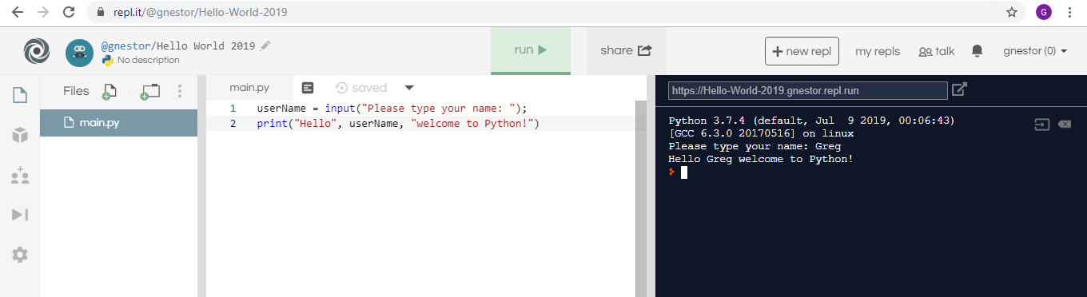

* 1. Summarize the function of each panel

1. File Chooser
   * Each Python may have many files (You can add files and folders)
   * "main.py" is your main program file
2. Program Editor
   * Type and edit your program script
   * Click the "Run > / Stop" button to control your program
3. Console Input / Output
   * Displays the output and results of your program
   * Where you type to answer responses to input prompts from your program
   * Can also type and run short programs here (like a calculator)

**Student Questions:**

1. Create an account for yourself at www.repl.it
   1. Review the "Terms of Service" to verify that you can legally use this service.
   2. Follow the previous discussed guidelines regarding use of personal information
2. List the part of the "Terms of Service" that verifies that you can legally use this service.

The part of the "Terms of Service" that verifies that I can legally use this service is the Accounts; Account Termination Policy.

1. Explain some of the rights that you give away to Repl.it regarding content you create using their service?

You let them collect information that can be used to identify and contact you, such as name and email address. You agree not to alter or modify any part of the Service. You agree to not use the Service to attack or tamper with other websites, services, and individuals. You also agree not use the Service for commercial purposes unless you get written approval.

1. Create a new Python repl and call it "Hello World".
2. Copy and paste the following program into the program panel (white area)

userName = input("Please type your name: ");

print("Hello", userName, "welcome to Python!")

1. Run the program to see what it does. (If necessary, fix the quotation marks so it runs properly.)
   1. Explain how the program works.

This program works by insterting the command into the white space, like print("Hello World") abd executing the command in the black space, Hello World.

* 1. Explain how you fixed the program (if necessary)

1. Try using the console pane (black area) to perform some simple calculations and run some one-line programs.
   1. Summarize some of your calculations.

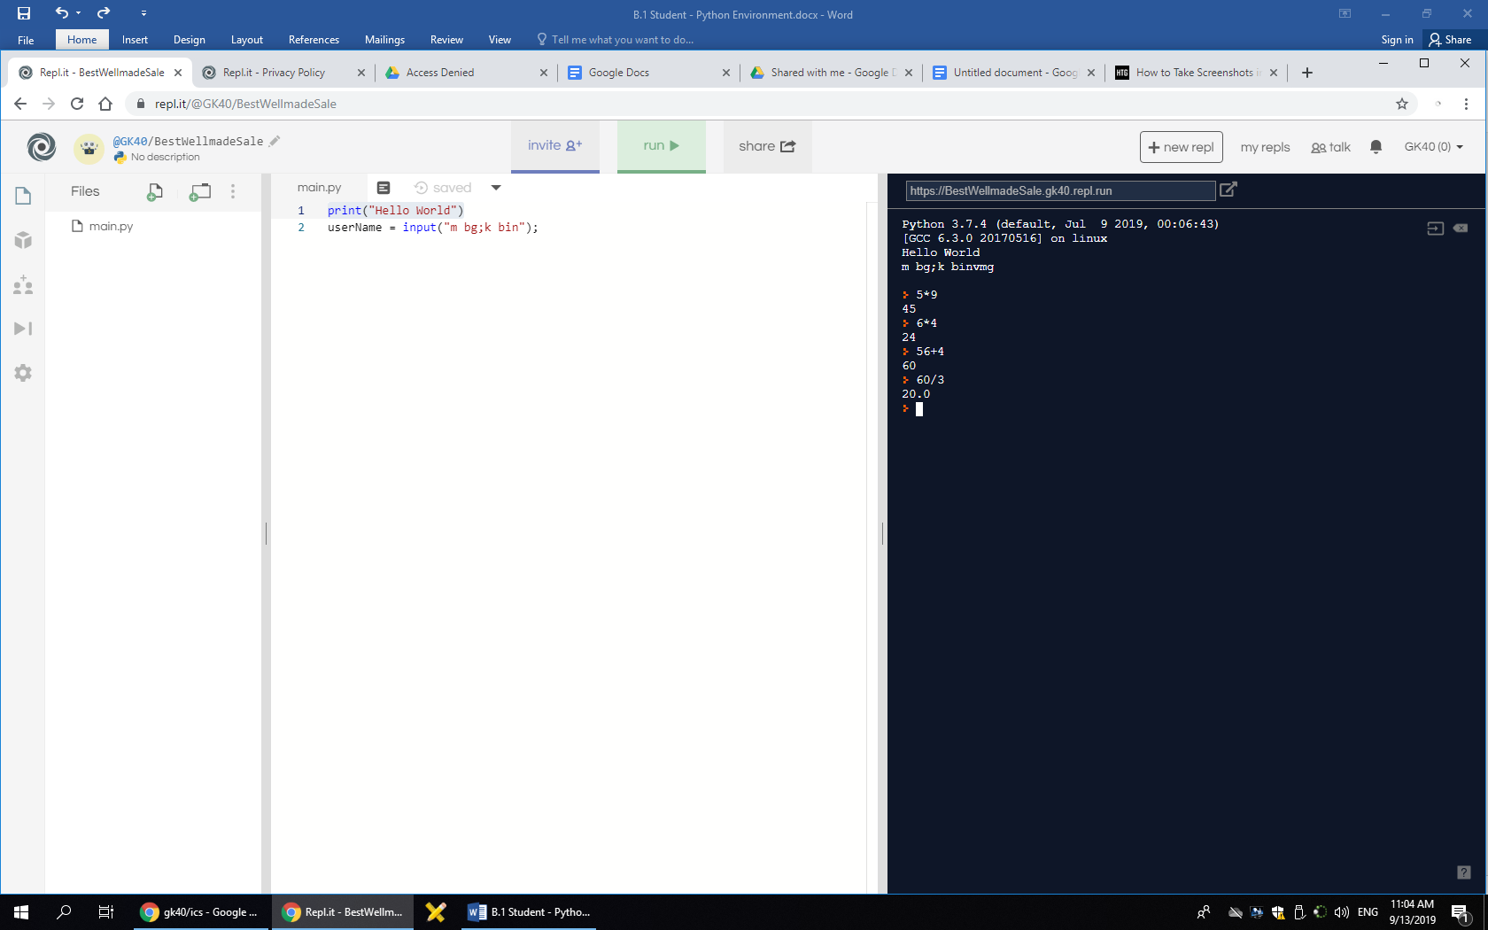

1. Try using the file management pane to add some files and folders to your repl.
   1. Summarize some of your additions.

I made a “dummy” folder and added the files into the folder by dragging them.